Chapter 5 Demo!

Step 1: Relabel the question into a research and null hypothesis:

Research:

Null:

Step 2 Comparison distributions:

|  |  |
| --- | --- |
| Z-scores use the normal distribution: | Z-tests use the distribution of means: |
| We used:  Population mean = mu (u)  Populations standard deviation = sigma (o)  One person = X | Population mean: Formula_05  Population standard deviationFormula_05  Sample M = average of scores  N – the number of people in the study: |

|  |  |
| --- | --- |
| Your score: | Sample M =  Population um =  Standard deviation of distribution of samples om = |
| Other score: |
| Other score: |
| Other score: |
| Other score: |

Step 3: Cut off scores on the comparison distribution:

Step 4: Find the sample score:

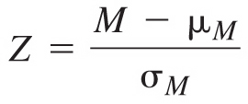

Step 5: Do you reject the null hypothesis?